GUIDELINES

(By Subrata Sir & group of ICSE and CBSE school teachers)

*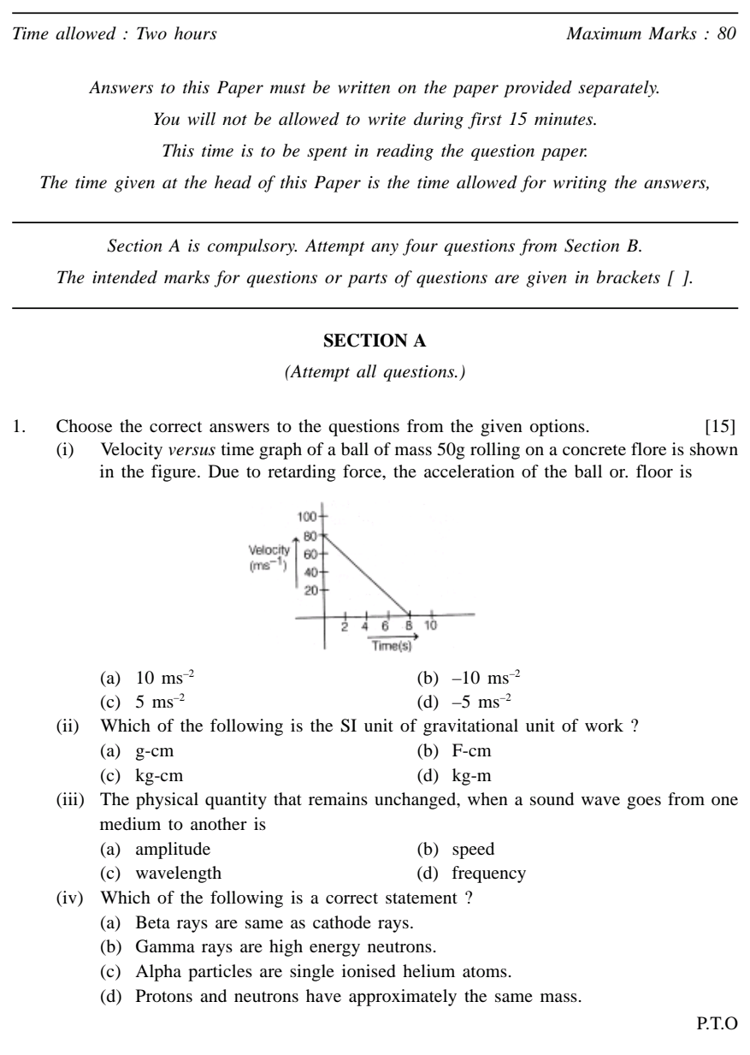***ICSE Physics–2023   
(Mock Paper-2)**

*Time allowed : Two hours Maximum Marks : 80*

*Answers to this Paper must be written on the paper provided separately.   
You will not be allowed to write during first 15 minutes.   
This time is to be spent in reading the question paper.   
The time given at the head of this Paper is the time allowed for writing the answers,*

*Section A is compulsory. Attempt any four questions from Section B.   
The intended marks for questions or parts of questions are given in brackets [ ].*

**SECTION A***(Attempt all questions.)*

1. Choose the correct answers to the questions from the given options. [15]

(i) Velocity *versus* time graph of a ball of mass 50g rolling on a concrete flore is shown   
in the figure. Due to retarding force, the acceleration of the ball or. floor is

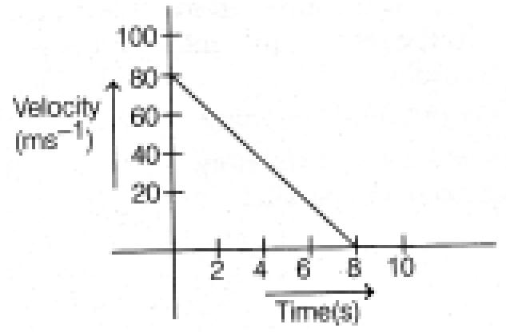

(a) 10 ms–2 (b) –10 ms–2

(c) 5 ms–2 (d) –5 ms–2

1. Which of the following is the SI unit of gravitational unit of work?

(a) g-cm (b) F-cm

(c) kg-cm (d) kg-m

1. The physical quantity that remains unchanged, when a sound wave goes from one medium to another is

(a) amplitude (b) speed

(c) wavelength (d) frequency

1. Which of the following is a correct statement?
2. Beta rays are same as cathode rays.
3. Gamma rays are high energy neutrons.
4. Alpha particles are single ionized helium atoms.
5. Protons and neutrons have approximately the same mass.

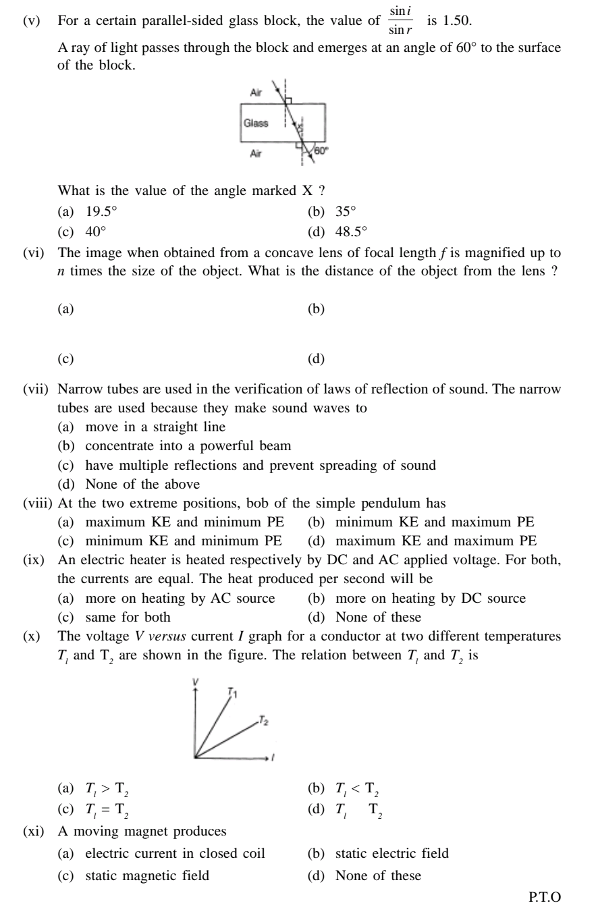(v) For a certain parallel-sided glass block, the value of sin *r* is 1.50.

A ray of light passes through the block and emerges at an angle of 60° to the surface of the block.

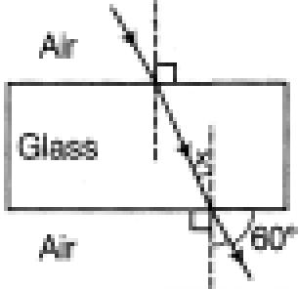

What is the value of the angle marked X ?

(a) 19.5° (b) 35°

(c) 40° (d) 48.5°

(vi) The image when obtained from a concave lens of focal length *f* is magnified up to *n* times the size of the object. What is the distance of the object from the lens ?

(a) (b)

(c) (d)

(vii) Narrow tubes are used in the verification of laws of reflection of sound. The narrow tubes are used because they make sound waves to

1. move in a straight line
2. concentrate into a powerful beam
3. have multiple reflections and prevent spreading of sound
4. None of the above

(viii) At the two extreme positions, bob of the simple pendulum has

(a) maximum KE and minimum PE (b) minimum KE and maximum PE (c) minimum KE and minimum PE (d) maximum KE and maximum PE

(ix) An electric heater is heated respectively by DC and AC applied voltage. For both, the currents are equal. The heat produced per second will be

(a) more on heating by AC source (b) more on heating by DC source

(c) same for both (d) None of these

(x) The voltage *V versus* current *I* graph for a conductor at two different temperatures *Tl* and T*2* are shown in the figure. The relation between *Tl* and *T2* is

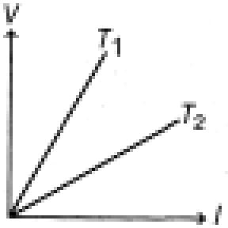

(a) *Tl* > T*2* (b) *Tl* < T*2*

(c) *Tl* = T*2* (d) *Tl* T*2*

(xi) A moving magnet produces

(a) electric current in closed coil (b) static electric field

(c) static magnetic field (d) None of these

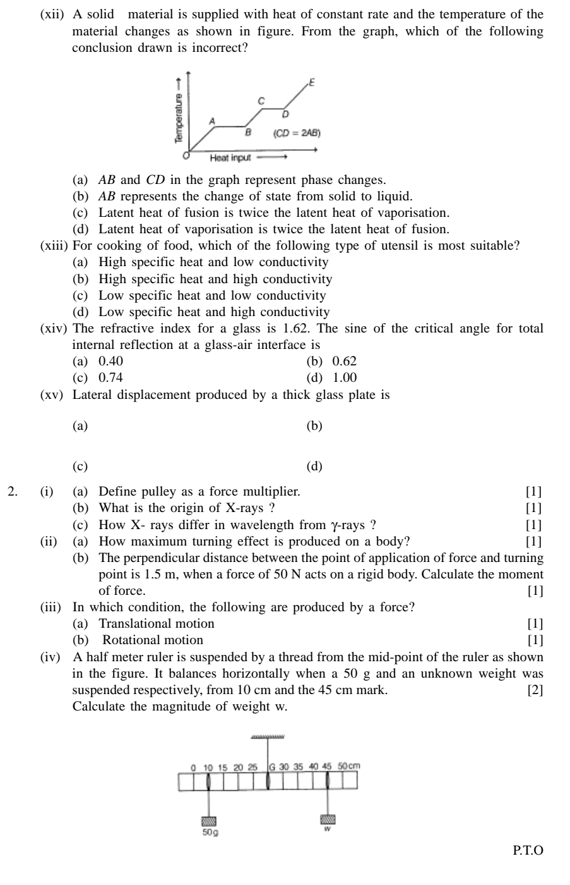(xii) A solid material is supplied with heat of constant rate and the temperature of the material changes as shown in figure. From the graph, which of the following conclusion drawn is incorrect?

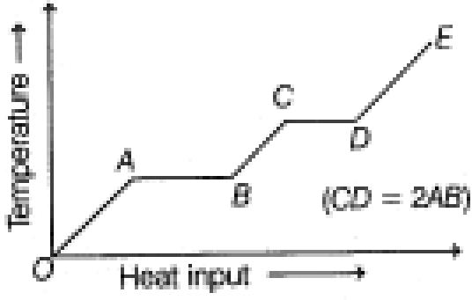

1. *AB* and *CD* in the graph represent phase changes.
2. *AB* represents the change of state from solid to liquid.
3. Latent heat of fusion is twice the latent heat of vaporisation.
4. Latent heat of vaporisation is twice the latent heat of fusion.

(xiii) For cooking of food, which of the following type of utensil is most suitable?

1. High specific heat and low conductivity
2. High specific heat and high conductivity
3. Low specific heat and low conductivity
4. Low specific heat and high conductivity

(xiv) The refractive index for a glass is 1.62. The sine of the critical angle for total internal reflection at a glass-air interface is

(a) 0.40 (b) 0.62

(c) 0.74 (d) 1.00

(xv) Lateral displacement produced by a thick glass plate is

2. (i) (a) Define pulley as a force multiplier. [1]

1. What is the origin of X-rays ? [1]
2. How X- rays differ in wavelength from γ-rays ? [1]

(ii) (a) How maximum turning effect is produced on a body? [1]

(b) The perpendicular distance between the point of application of force and turning point is 1.5 m, when a force of 50 N acts on a rigid body. Calculate the moment of force. [1]

(iii) In which condition, the following are produced by a force?

1. Translational motion [1]
2. Rotational motion [1]

(iv) A half meter ruler is suspended by a thread from the mid-point of the ruler as shown in the figure. It balances horizontally when a 50 g and an unknown weight was suspended respectively, from 10 cm and the 45 cm mark. [2] Calculate the magnitude of weight w*.*

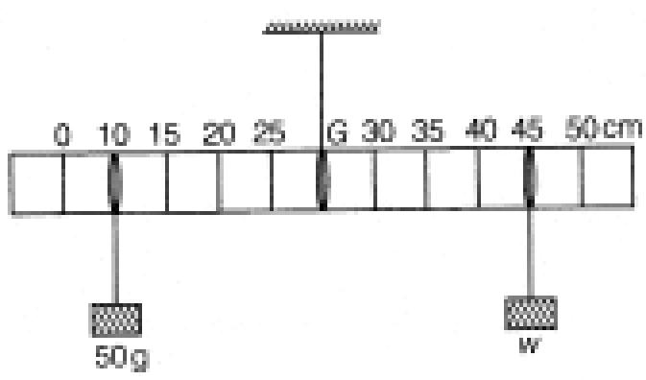

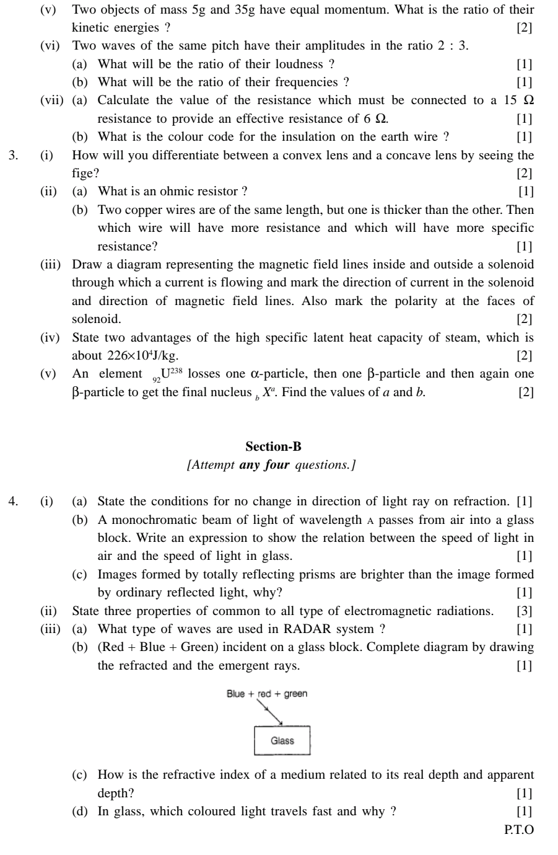(v) Two objects of mass 5g and 35g have equal momentum. What is the ratio of their kinetic energies ? [2]

(vi) Two waves of the same pitch have their amplitudes in the ratio 2 : 3.

1. What will be the ratio of their loudness ? [1]
2. What will be the ratio of their frequencies ? [1]

(vii) (a) Calculate the value of the resistance which must be connected to a 15 Ω

resistance to provide an effective resistance of 6 Ω*.* [1]

(b) What is the colour code for the insulation on the earth wire ? [1]

3. (i) How will you differentiate between a convex lens and a concave lens by seeing the

fige? [2]

1. (a) What is an ohmic resistor ? [1]

(b) Two copper wires are of the same length, but one is thicker than the other. Then which wire will have more resistance and which will have more specific resistance? [1]

1. Draw a diagram representing the magnetic field lines inside and outside a solenoid through which a current is flowing and mark the direction of current in the solenoid and direction of magnetic field lines. Also mark the polarity at the faces of solenoid. [2]
2. State two advantages of the high specific latent heat capacity of steam, which is about 226×104J/kg. [2]
3. An element 92U238 losses one α-particle, then one β-particle and then again one β-particle to get the final nucleus *b Xa.* Find the values of *a* and *b.* [2]

**Section-B**

*[Attempt* ***any four*** *questions.]*

4. (i) (a) State the conditions for no change in direction of light ray on refraction. [1]

(b) A monochromatic beam of light of wavelength A passes from air into a glass block. Write an expression to show the relation between the speed of light in air and the speed of light in glass. [1]

(c) Images formed by totally reflecting prisms are brighter than the image formed

by ordinary reflected light, why? [1]

1. State three properties of common to all type of electromagnetic radiations. [3]
2. (a) What type of waves are used in RADAR system ? [1]   
   (b) (Red + Blue + Green) incident on a glass block. Complete diagram by drawing the refracted and the emergent rays. [1]

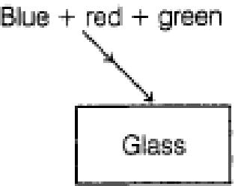

1. How is the refractive index of a medium related to its real depth and apparent

depth? [1]

1. In glass, which colored light travels fast and why? [1]

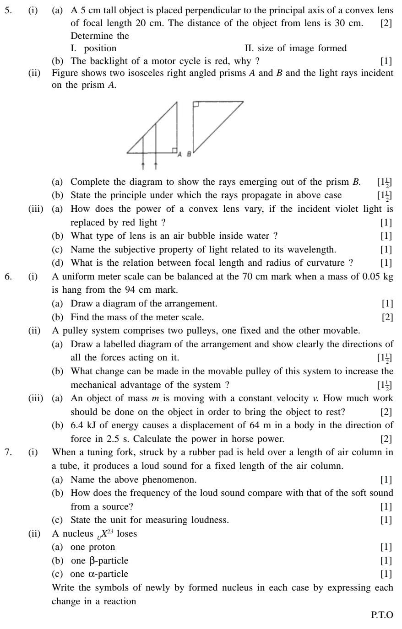

5. (i) (a) A 5 cm tall object is placed perpendicular to the principal axis of a convex lens

of focal length 20 cm. The distance of the object from lens is 30 cm. [2]

Determine the

I. position II. size of image formed

(b) The backlight of a motor cycle is red, why? [1]

(ii) Figure shows two isosceles right angled prisms *A* and *B* and the light rays incident on the prism *A.*

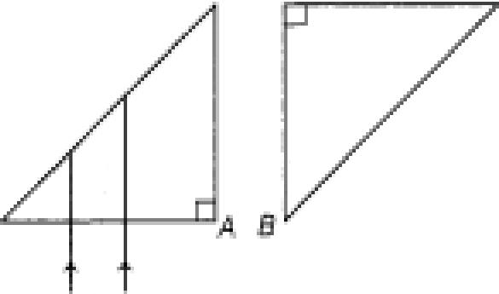

1. Complete the diagram to show the rays emerging out of the prism *B.* [11--
2. State the principle under which the rays propagate in above case [11**-**2]

(iii) (a) How does the power of a convex lens vary, if the incident violet light is

replaced by red light ? [1]

(b) What type of lens is an air bubble inside water ? [1]

1. Name the subjective property of light related to its wavelength. [1]
2. What is the relation between focal length and radius of curvature ? [1]

6. (i) A uniform meter scale can be balanced at the 70 cm mark when a mass of 0.05 kg

is hang from the 94 cm mark.

1. Draw a diagram of the arrangement. [1]
2. Find the mass of the meter scale. [2]

(ii) A pulley system comprises two pulleys, one fixed and the other movable.

1. Draw a labelled diagram of the arrangement and show clearly the directions of all the forces acting on it. [11--2]
2. What change can be made in the movable pulley of this system to increase the mechanical advantage of the system ? [11--2]

(iii) (a) An object of mass *m* is moving with a constant velocity *v.* How much work should be done on the object in order to bring the object to rest?

(ii) Write the symbols of newly by formed nucleus in each case by expressing each change in a reaction

force in 2.5 s. Calculate the power in horse power. [2]

7. (i) When a tuning fork, struck by a rubber pad is held over a length of air column in

a tube, it produces a loud sound for a fixed length of the air column.

1. Name the above phenomenon. [1]
2. How does the frequency of the loud sound compare with that of the soft sound

|  |  |
| --- | --- |
| ( c ) State the unit for measuring loudness. | [1] |

|  |  |
| --- | --- |
| from a source? | [1] |
|  |  |
| A nucleus *UX23* loses   1. one proton | [1] |
| 1. one β-particle | [1] |
| 1. one α-particle |  |

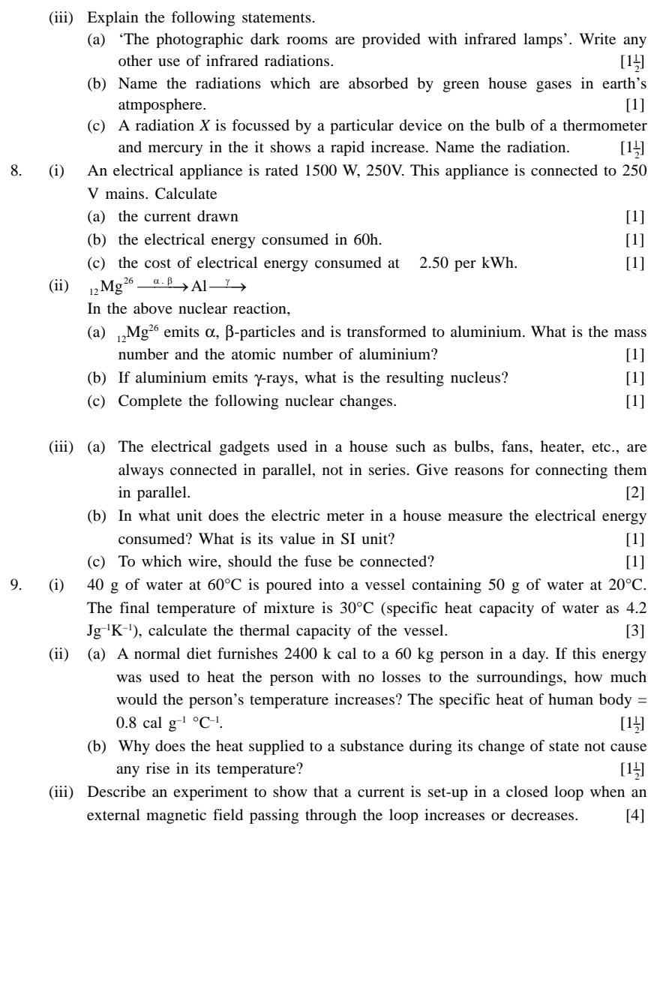

(iii) Explain the following statements.

1. ‘The photographic dark rooms are provided with infrared lamps’. Write any other use of infrared radiations. [11--2]
2. Name the radiations which are absorbed by green house gases in earth’s atmposphere. [1]
3. A radiation *X* is focussed by a particular device on the bulb of a thermometer

and mercury in the it shows a rapid increase. Name the radiation. [11--2]

8. (i) An electrical appliance is rated 1500 W, 250V. This appliance is connected to 250

V mains. Calculate (a) the current dr

1. the electrical energy consumed in 60h. [1]
2. the cost of electrical energy consumed at 2.50 per kWh. [1]

26 . γ

(ii) 12Mg ⎯⎯⎯→ ⎯⎯→

α β Al

In the above nuclear reaction,

1. 12Mg26 emits α, β-particles and is transformed to aluminium. What is the mass

number and the atomic number of aluminium? [1]

1. If aluminium emits γ-rays, what is the resulting nucleus? [1]
2. Complete the following nuclear changes. [1]